**Lab 4**

***(Show input and output side by side for all problems****)*

1. **Sharpen** the following image by applying the following and find out which one is better:
2. **Unsharp Masking**
3. **High Boost Filtering**

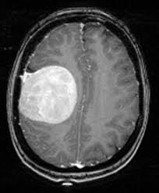

1. **Sharpen** the following image using the concept of **Laplacian Filtering**.

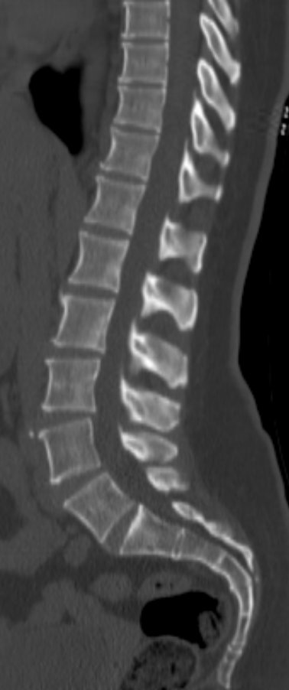

1. **Use** **Roberts-cross, Sobel,** and **Prewitt** operators to detect the edge of the following image.

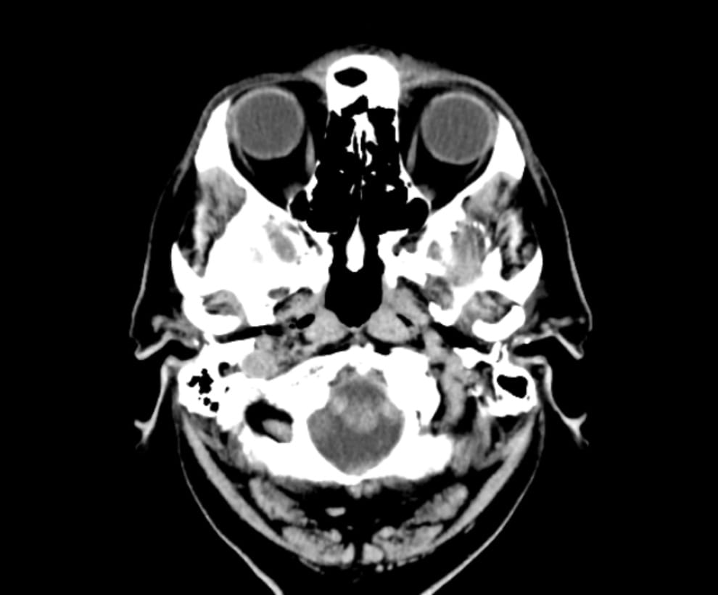

1. **Show** performance comparison among High Boost, Unsharp, Laplacian Roberts-cross, Sobel, Prewitt and Canny filtering for edge detection – find out which one is better for the given image.